Astrosage Analysis

Objective Questions:

- What is the total no. of tables present in the data?
Answer:- One table.
- What is the total no. of attributes present in the data?
Answer:-The database contains 41 attributes after adding the missing columns.
- The data consists of some inconsistent and missing values so ensure that the data used for further analysis is cleaned.
Answer:- The dataset was cleaned and prepared before analysis:
- Handled Inconsistent Categorical Values:
  - Standardized text in categorical columns queue to ensure consistency.
- Added Needed Columns:
  - Created helper columns, such as hour/time slots from CreatedAt .
- Converted Data Types:
  - Converted columns like userOnCallDuration into consistent numeric format.
  - Extracted date, month and time from CreatedAt for easier aggregation and visualization.
The dataset was ready for PivotTables, charts, and dashboard creation, ensuring accurate and reliable analysis.
- What is the change in daily call volume day by day and also find the average daily call volume.
Answer:-
Change in Daily Call Volume:
- A PivotTable was created with CreatedAt (grouped by date) in rows and CallSid in values (Count).
- Then Show value as different from previous day.
- This shows the day-to-day increase or decrease in call volume.

Average Daily Call Volume:

- Calculated using the AVERAGE function on the daily call counts from the PivotTable:
- =AVERAGE(DailyCallCountsRange)
- This gives the average number of calls handled per day.

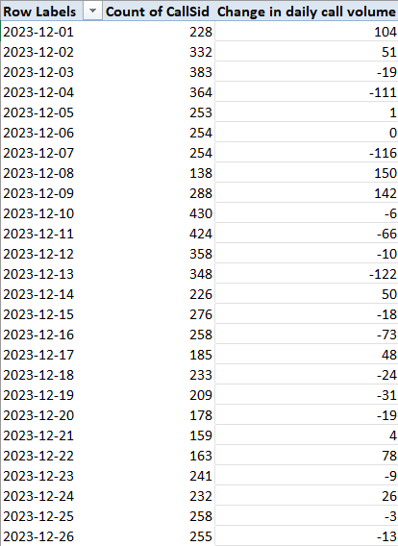

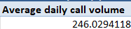

- Which months experienced the highest and lowest call volumes?
Answer:- Monthly Call Volume Analysis:
- The CreatedAt column was grouped by month in a PivotTable.
- CallSid was used in Values → Count to calculate the total calls per month.

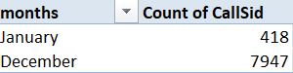

- What is the total operational cost for that month?
Answer:- Calculation of Monthly Operational Cost:
  - A PivotTable was created with CreatedAt grouped by month in the rows.
  - The amount column (representing charges for each session) was added in Values → Sum.
  - This gives the total operational cost for each month.
Considerations:
  - Only valid, cleaned entries were included to ensure accuracy.
  - Refunds or free calls can be excluded if focusing on actual revenue/operational cost.

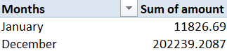

- What is the average number of calls handled per agent per day?
Answer:- Calculation Method:
- A PivotTable was created with guruName (agent) in Rows and CreatedAt grouped by day in Columns.
- CallSid was added in Values → Count to get the number of calls handled per agent per day.
Average Calculation:
- A helper column was added beside the PivotTable to calculate the daily call count per agent.
- The AVERAGE function was used to compute:
- =AVERAGE(DailyCallCountsRange)
- This gives the average number of calls handled by each agent per day.
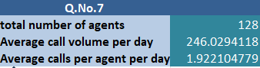

- How many repeat callers are there, and what percentage of total calls do they represent?
Answer:- Identification of Repeat Callers:
- Using the user column (unique user ID), a PivotTable was created.
- Users with more than one CallSid were considered repeat callers.
- Count of these users gives the total number of repeat callers.
Percentage of Total Calls:
- Total calls =8363.
- Percentage of calls from repeat users was calculated using:
= (4735 / 8363) * 100 = 56.62%

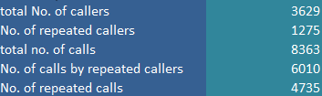

- What are the total sales generated by the call centre for each product category?
Answer:- Calculation of Total Sales by Product Category:
- A PivotTable was created with consultationType (product category) in Rows.
- amount column was added in Values → Sum to calculate total sales for each category.
Considerations:
- Only valid entries were included to ensure accuracy.
- Refunds or free sessions can be filtered out if focusing on actual revenue.
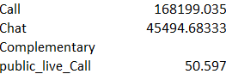

- How many calls were made for each user ID and guru ID?
Answer:- Calculation of Calls per User and Guru:
- A PivotTable was created with user and guruName / guruID in Rows.
- CallSid was added in Values → Count to determine the number of calls for each combination of user and guru.

Result:
- This shows how many calls each user made and which guru handled them, helping management analyze user engagement and guru workload.
- The PivotTable can also be sorted to identify top users or busiest gurus.
Reference: in objective question answer spreedsheet
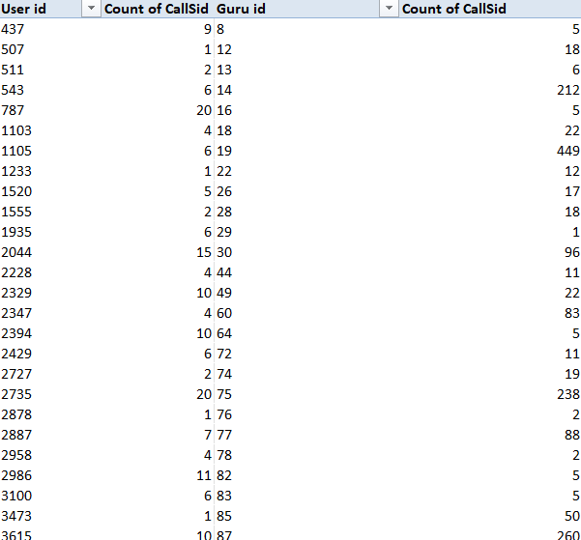

- What is the correlation between call duration and customer satisfaction?
Answer:- Calculation of Correlation:
- The columns userOnCallDuration (call duration in consistent units) and rating (customer satisfaction) were used.
- A correlation coefficient was calculated using Excel:
- =CORREL(userOnCallDurationRange, ratingRange)
- This measures the strength and direction of the relationship between call duration and customer satisfaction.
Interpretation:
- A positive correlation indicates that longer calls tend to have higher satisfaction.
- A negative correlation indicates that longer calls may lead to lower satisfaction.
- A value close to 0 suggests little or no linear relationship.
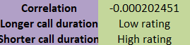

- Which guru has the highest and lowest customer satisfaction scores?
Answer:- Calculation of Guru-wise Customer Satisfaction:
- A PivotTable was created with guruName in Rows.
- rating was added in Values → Average to calculate the average customer satisfaction score for each guru.
Identifying Extremes:
- Sorting the PivotTable descending by average rating shows the guru with the highest satisfaction.
- Sorting ascending shows the guru with the lowest satisfaction.
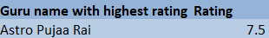


- What is the average customer satisfaction score by month?
Answer:- Calculation of Monthly Average Customer Satisfaction:
- A PivotTable was created with CreatedAt grouped by month in Rows.
- rating was added in Values → Average to calculate the average customer satisfaction score for each month.
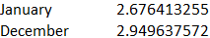

- How many categorical columns are there in the data?
Answer:- Categorical Columns:-
statementEntryId, callChannel, calIvrType, callStatus, CallSid, astrologerCallStatus, region, userCallStatus, user, chatStatus, guru, guruName, gid, uid, consultationType, website, Refund Status, is WhiteList User, queue, FreeCall, Free Chat, Month, Day, Year, Date
Total = 25 categorical columns.

Subjective Question

- Should the investment be used to hire more agents, improve training programs, or upgrade call center technology?

Answer:- The investment decision depends on analyzing call center performance metrics.
- Hiring More Agents: average rating is low, so they need to hire more agents.
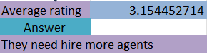

- Improving Training Programs: Needed if agents are handling calls but customer satisfaction scores are low, indicating a need for skill enhancement.

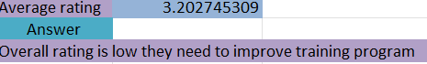

- Upgrading Call Center Technology: Useful if inefficiencies exist in call handling, IVR, or routing, which increase call duration or repeat calls.
So they need to upgrade there call center technology.
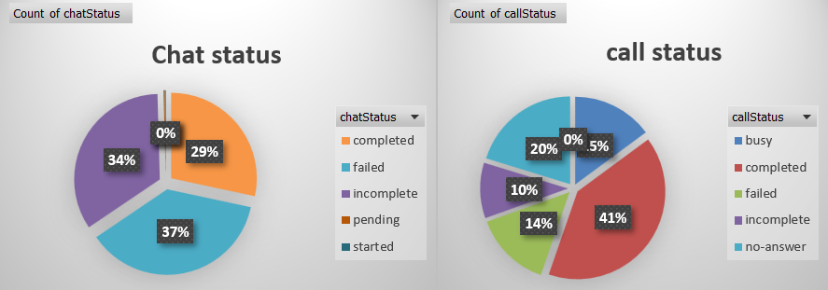

Recommendation: A combined approach works best: hire additional agents to manage peak loads, train agents to improve service quality, and upgrade technology to enhance efficiency.

- What are the potential risks of each investment option (hiring, training, technology upgrades), and how can they be mitigated?

Answer:- Potential Risks and Mitigation:
- Hiring More Agents:
  - Risk: Higher operational costs if call volume does not increase as expected.
  - Mitigation: Analyze historical call volume trends using PivotTables and line charts to ensure staffing matches demand.
- Improving Training Programs:
  - Risk: Time and cost investment may not immediately improve customer satisfaction.
  - Mitigation: Track agent performance before and after training using average rating per agent in a PivotTable and bar charts to measure impact.
- Upgrading Technology:
  - Risk: High initial investment and potential downtime during implementation.
  - Mitigation: Identify inefficiencies through call duration, queue analysis, and repeat calls using PivotTables and line/bar charts, and implement upgrades in phases.

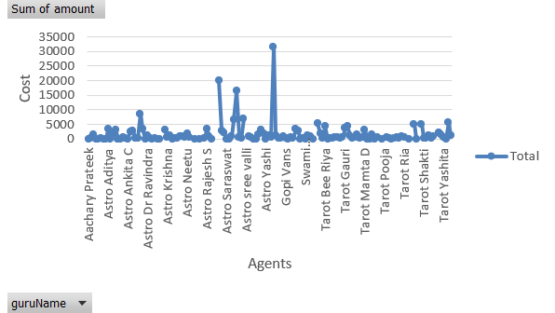

Spreadsheet Functions and Visualizations Used:
- PivotTables for grouping and aggregating call metrics
- Sum functions for measuring performance
- Line charts for trends over time

- How does AstroSage's call center performance compare to AstroGuru's average call volume, customer satisfaction, and agent performance?
Answer:- To compare AstroSage’s call center performance with AstroGuru’s, we analyze three metrics:
- Call Volume: Use COUNT of CallSid in a PivotTable to calculate total and average daily calls.

- Customer Satisfaction: Use AVERAGE of rating to compare average satisfaction scores per month or per agent.
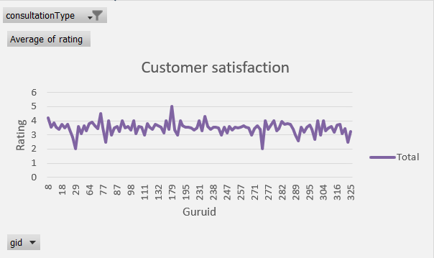

- Agent Performance: Use COUNT of calls handled per agent to assess workload and efficiency.
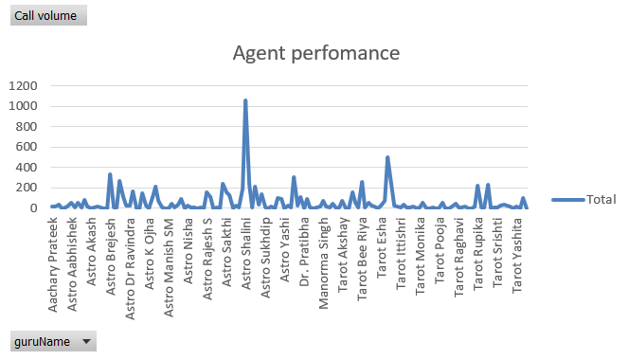

Visualization:
- Bar charts or line charts can show trends in call volume, satisfaction, and agent performance over time.
- PivotTables aggregate data for comparisons, while charts make it easy to visually compare metrics between AstroSage and AstroGuru.

- How can the call center improve its handling of peak call periods to ensure high customer satisfaction?

Answer:- To improve handling of peak call periods and maintain high customer satisfaction, the call center can:

- Analyze Peak Call Hours: Use PivotTables with CreatedAt grouped by hour and COUNT of CallSid to identify periods with the highest call volume.
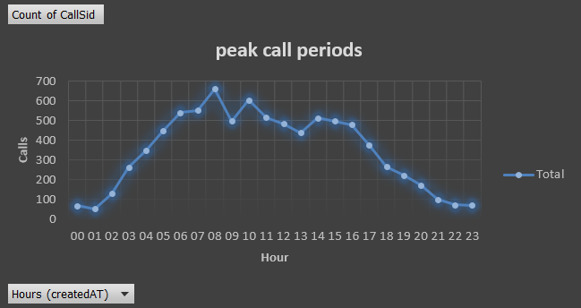
- Optimize Staffing: Compare call volume with average calls handled per agent to ensure adequate staffing during peak hours.

- Reduce Wait Times: Monitor queue metrics and identify bottlenecks using line charts or bar charts.

- Improve Efficiency: Train agents and upgrade technology if high call volumes lead to longer call durations or repeat calls.
Functionality Used:

- PivotTables for aggregating call volume by time
- COUNT and AVERAGE functions for metrics
- Line and bar charts to visualize peak periods and agent workload

Insights :-
The hourly call distribution analysis (reference: call distribution over hours chart) shows that call volumes peak during specific time slots, particularly in the evening hours. During these peak periods, customer satisfaction scores tend to decline slightly, indicating longer wait times and increased agent workload. Additionally, repeat callers are more frequent during peak hours, suggesting unresolved issues or rushed interactions.

Recommendations:-

- Dynamic Workforce Allocation:
Based on peak-hour aggregation (PivotTable using COUNT of CallSid by hour), additional agents should be scheduled during high-volume time slots to reduce wait times.

- Skill-Based Call Routing:
Using call status and consultation type data, calls should be routed to experienced or higher-rated agents during peak hours to maintain service quality.

- Peak-Hour Performance Monitoring:
Dashboards should track satisfaction ratings and call durations specifically during peak periods to identify real-time bottlenecks.

- Self-Service & Automation:
Introducing IVR enhancements and automated responses for common queries can reduce agent load during peak times.

- Based on historical data, what strategic initiatives should be prioritized to improve efficiency and customer satisfaction?

Answer:- Insight :-
Customer ratings were compared across consultation type (Call, Chat, Complementary, Public Live Call) and website/source using aggregated analysis.
The PivotTable analysis (AVERAGE of rating grouped by consultation type and website) shows noticeable variation in customer satisfaction scores. Call-based consultations generally receive higher average ratings compared to chat-based consultations, indicating that real-time verbal interaction leads to better problem resolution and customer confidence.

Additionally, ratings vary across platforms, with some websites consistently showing higher satisfaction, suggesting differences in user expectations, service quality, or technical experience.
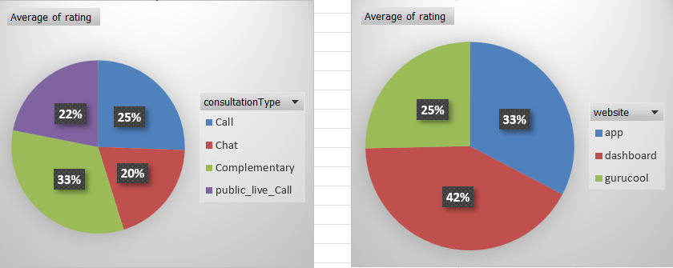

Patterns and Discrepancies Identified:
- Consultation Type:
Call consultations have higher average ratings than chat consultations, as longer and more personalized interactions positively influence customer satisfaction. Complementary sessions tend to have lower ratings, possibly due to limited interaction time or perceived lower value.
- Website / Platform:
Certain platforms demonstrate higher satisfaction scores, while others show inconsistent ratings. This indicates possible technical issues, differences in service flow, or user demographics affecting experience.
- Interaction Quality:
Longer call durations in call consultations are moderately correlated with higher ratings, reinforcing the importance of effective engagement.

Tools / Functionality Used:-

- PivotTables – Average rating by consultation type and website.
- AVERAGE Function – To compute satisfaction trends.
- Column / Bar Charts – Visual comparison of ratings across platforms and consultation types.
- Slicers – To filter analysis by time period or consultation type.

Recommendations :-
- Prioritize call-based consultations during peak periods for high-value customers.
- Improve chat workflow and response templates to enhance satisfaction in chat consultations.
- Standardize service quality across websites by identifying best-performing platforms and replicating their practices.
- Monitor ratings continuously by consultation type and platform through dashboards to detect early drops in satisfaction.

- What can be the key factors contributing to high customer satisfaction scores, and how can these be leveraged to improve overall performance?
What is the basis for the suggestions? And mention how you decided if the satisfaction score affects the ratings.

Answer:- Key Factors Contributing to High Customer Satisfaction:

- Call Duration: Adequate time spent per call ensures customer queries are resolved. PivotTables with userOnCallDuration and rating help identify optimal durations.
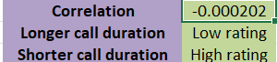

- Agent Performance: Gurus/agents with higher average ratings consistently provide better service. Use AVERAGE of rating per guru in PivotTables to identify top performers.
- Call Handling Efficiency: Fewer abandoned or failed calls (callStatus analysis) lead to higher satisfaction.
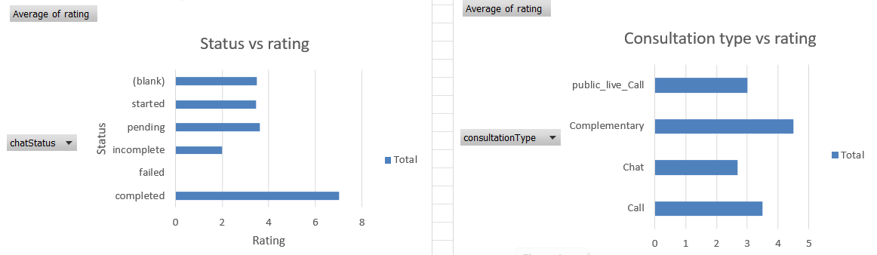

Leveraging Factors for Improvement:-

- Assign high-performing agents to peak hours and challenging queries.
- Provide training to improve efficiency and service quality.
- Optimize call routing and IVR to reduce wait times and call failures.
Basis for Suggestions:
- Analysis of PivotTables, averages, and correlation between userOnCallDuration and rating.
- A positive correlation indicates that longer or well-managed calls tend to increase satisfaction.
Insights:-

Analysis of ratings against call duration, call status, consultation type, and website shows that customer satisfaction is higher for completed calls, longer but meaningful interactions, and call-based consultations compared to chat. Certain platforms consistently record better ratings, indicating more stable service flow or better user experience.

Recommendation:-
- Train agents to maintain optimal call duration that ensures issue resolution without rushing.
- Reduce call failures by improving call routing and technical stability.
- Enhance chat consultation workflows and escalate complex chats to calls.
- Replicate best practices from high-performing platforms across all websites.

- How should the call center balance the workload among agents to ensure optimal performance and avoid burnout?
Mention your approach and spreadsheet function for the answer.

Answer:- To balance workload among agents and ensure optimal performance while avoiding burnout:

- Analyze Call Distribution: Use PivotTables with guruName or agent ID in Rows and CallSid in Values → Count to calculate the number of calls handled by each agent.

- Identify Workload Imbalance: Compare average calls per agent per day using AVERAGE function. Agents handling significantly higher volumes may be at risk of burnout.

- Reallocate Calls: Adjust schedules or assign additional agents during peak hours to distribute calls more evenly.

- Monitor Performance: Track customer satisfaction ratings alongside call volumes to ensure quality is maintained.

PivotTable analysis comparing calls handled per agent per day, average call duration, and customer ratings shows uneven workload distribution across agents. Some agents consistently handle a higher number of calls with longer durations, which correlates with slightly declining ratings over time. Agents with balanced call loads maintain more stable satisfaction scores, indicating that excessive workload negatively impacts performance and customer experience.

Recommendations :-
- Implement workload-based call allocation using average calls per agent per day to distribute calls evenly.
- Use agent performance dashboards to monitor call volume, duration, and ratings in real time.
- Schedule rotational breaks and shift balancing during peak hours based on hourly call volume analysis.
- Assign complex or long-duration calls to experienced agents to reduce stress on newer agents.

Spreadsheet Functionality Used:
- PivotTables for aggregation
- COUNT and AVERAGE functions for calculating workload metrics
- Bar charts to visualize call distribution per agent

- What new technologies or tools could be implemented to enhance call center operations and customer service?
Answet:- To enhance call center operations and improve customer service, the following technologies and tools can be implemented:

- Advanced IVR Systems: Intelligent call routing reduces wait times and ensures customers are connected to the right agent quickly.

- Call Analytics and Dashboards: Tools that monitor call volume, duration, agent performance, and customer satisfaction in real-time to support data-driven decisions.

- CRM Integration: Customer relationship management systems help agents access customer history and preferences, improving service quality.

- AI-Powered Chatbots: Handle routine queries and free agents for more complex calls, reducing workload during peak periods.

- Call Recording and Quality Monitoring Tools: Analyze interactions for training and performance improvement.

- What metrics should be included in the final dashboard to comprehensively view call center performance and guide investment decisions?
Answer:- The final dashboard should include the following key metrics to comprehensively view call center performance and guide investment decisions:

Key Metrics:-

Call Volume Metrics:-
Daily and monthly call volume (COUNT of CallSid) highlight demand patterns and peak periods. Hourly call distribution identifies congestion windows, helping management plan staffing and reduce wait times.

Agent Performance Metrics:-
Average calls handled per agent per day and average call duration reveal workload balance and efficiency. Analysis shows uneven call distribution across agents, which may lead to burnout and inconsistent service quality.

Customer Satisfaction Metrics:-
Average rating by consultation type, guru, and platform provides insight into service quality. Call-based consultations and completed calls consistently show higher ratings, confirming that interaction quality directly affects satisfaction.

Financial Metrics:-
Total sales, net amount, and astrologer earnings by consultation type and guru indicate revenue drivers. Certain consultation types contribute disproportionately to revenue, highlighting areas for focused growth.

Repeat Caller Metrics:-
Repeat user analysis (COUNT of CallSid by user ID) identifies customer loyalty and potential service gaps. High repeat call rates during peak hours may indicate unresolved issues.

Insights:-

- Peak hours experience higher call volumes but slightly lower satisfaction scores.
- Balanced agent workloads correlate with stable ratings.
- Call consultations outperform chat in both satisfaction and revenue generation.
- Revenue concentration in specific consultation types suggests optimization opportunities.
Recommendations:-

- Increase staffing or automation during peak hours.
- Balance agent workloads using performance-based routing.
- Prioritize high-performing consultation types and platforms.
- Continuously monitor satisfaction and repeat callers through interactive dashboards.

- How would you allocate a 1 crore rupee investment to optimize operational efficiency, enhance customer satisfaction, and boost profitability, and what analysis-based recommendations would you offer to support this?

Answer:- To optimally allocate a ₹1 crore investment for the call center, the allocation should be based on historical performance data and areas with the highest potential impact:-

- Hiring More Agents (40% – ₹40 lakh):
  - Analysis of peak-hour call volumes using PivotTables and line charts shows periods of high load.
  - Additional agents reduce wait times and prevent agent burnout, improving customer satisfaction.

- Training Programs (30% – ₹30 lakh):
  - Agents with lower average ratings are identified using PivotTables.
  - Targeted training improves service quality, reduces call handling errors, and enhances overall customer satisfaction.

- Technology Upgrades (30% – ₹30 lakh):
  - Analysis of call duration, queue metrics, repeat calls, and IVR performance highlights areas for improvement.
  - Upgrading IVR systems, implementing CRM tools, and analytics dashboards enhances operational efficiency and reduces repeat calls.

